**Monitoring of frailty and dependence with wearables and machine learning**

M. J. Rodríguez-Fórtiz, F. García-Moreno, M. Bermúdez-Edo, J. M. Pérez-Mármol, J. L. Garrido

**Purpose** Information and Communication Technologies are increasingly used to maintain a healthy aging, both for monitoring and intervention. Currently we are working in this line, contributing with a software system to collect and analyze health data from the elderly and their environment in a holistic (multi-sense, combining different sources of information) and ecological (while the users carry out their activities of daily living) way (García-Moreno et al, 2019) (Figure 1). We have developed a system with a microservice architecture, which self-adapts to the devices used to collect the data and the kind of analysis applied. Currently we are focusing on frailty and dependence, with the goal to prevent them, monitoring physical health, cognitive status, mental health (emotions) and social relationships. To perform holistic and ecological monitoring, we use wearables (e.g. writs, watches and headbands), and smartphones, which sensors also can collect environmental and physiological data from users. We federated sensory data with other health data and analyzed them to monitor the elderly and to detect anomalies; trying to prevent illnesses and dangerous situations. We use artificial intelligence techniques to analyze the data collected over time. With these techniques we identify patterns, classify individuals, and forecast health status. In particular, we have detected dependence, and frailty or pre-frailty status (associated for example with weight loss, depression or sadness, and social isolation). The early detection of these pathologies can trigger an intervention program in health to reverse these problems. **Method** The first phase of our method is the specification of the problem and the study of the system to solve it. We have analyzed the properties of different sensors, and techniques used to analyze physiological data, in related works. The second phase is the design and implementation of the solution. In our case, we have designed an adaptive architecture, and have selected several devices with sensors, a cloud storage for the data gathered, and machine learning algorithms (SVN, k-NN, RF, etc.) for analysis, implementing them as services and microservices. The last phase is the experimentation. Currently, we have designed one experiment in a real scenario, the purchase of a small item in a supermarket, to assess frailty and dependence. We have created different machine learning models to infer the frailty and dependence status with the sensory data. **Results and Discussion** We have developed an adaptable software system to evaluate the health status of the elderly in a holistic and ecological way. We have tested it in an experiment with 80 older adults. Our results indicate that it is possible to classify the frailty (99% accuracy using k-NN) and dependence (97% accuracy using k-NN with 10 features) status with sensory physiological data such as heart rate and electrodermal activity (García-Moreno et al, 2020) (García-Moreno et al, 2022). Currently we are working on improving the system to facilitate its adaptability to new devices and analysis techniques. Additionally, we are designing new experiments that focus on the monitoring of mental health, and social aspects, in contrast to the previous experiments focusing on physiological aspects. These three are the most important aspects in healthy aging.

**References**

Garcia-Moreno, F. M., Bermudez-Edo, M., Rodríguez-García, E., Pérez-Mármol, J. M., Garrido, J. L., & Rodríguez-Fórtiz, M. J. (2022). A machine learning approach for semi-automatic assessment of IADL dependence in older adults with wearable sensors. *International Journal of Medical Informatics, 157*, 104625. Q2 (50/161). <https://doi.org/10.1016/j.ijmedinf.2021.104625>

Garcia-Moreno, F. M., Bermudez-Edo, M., Garrido, J. L., Rodríguez-García, E., Pérez-Mármol, J. M., Rodríguez-Fórtiz, M. J. (2020). A microservices e-health system for ecological frailty assessment using wearables. *Sensors, 20*(12),3427. Q1. [https://doi.org/10.3390/s20123427](https://doi.org/10.3390/s2012342)

García-Moreno, F. M. , Rodríguez-García, E., Rodríguez-Fórtiz, M. J., Garrido, J. L., Bermúdez-Edo, M., Villaverde-Gutiérrez, C., Pérez-Mármol, J. M. (2019). Designing a smart mobile health system for ecological frailty assessment in elderly. *Multidisciplinary Digital Publishing Institute Proceedings, 31*(1), 41. <https://doi.org/10.3390/proceedings2019031041>

**Keywords:** frailty, dependence, services architecture, machine learning techniques

**Affiliation**: Department/Faculty, University name, country

**Corresponding Author Email:** [abc@gmail.com](mailto:abc@gmail.com); **Authors’ ORCID iDs:**

**Acknowledgement** This research was supported by ….

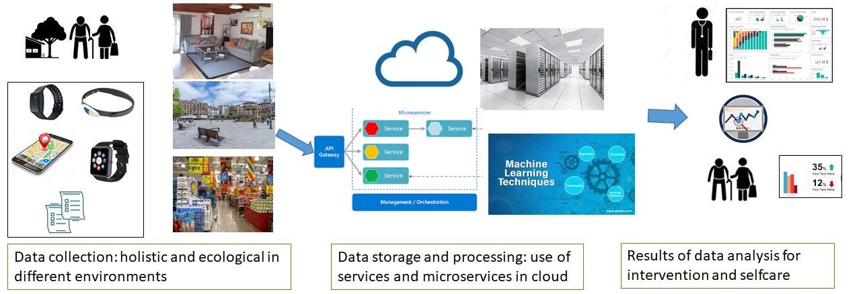

***Figure 1. Overview of the proposal***